What Are Under-Reported Stories, and How Can You Find Them?
Objective: You will be able to…
- Evaluate how you get their news, what stories you seek, why news is important, and questions you have about how the news is made
- Define the term “under-reported story” and describe examples of these stories
- Analyze how under-reported stories are different from other news stories and why they matter
- Evaluate how under-reported stories connect to issues you see in their communities, and brainstorm under-reported issues in their communities
- Practice methods for identifying and analyzing under-reported stories by evaluating news and conducting your own research.

Warm-up:
1. Brainstorm a definition for the word “news” below. How does your definition compare to the dictionary definition below?

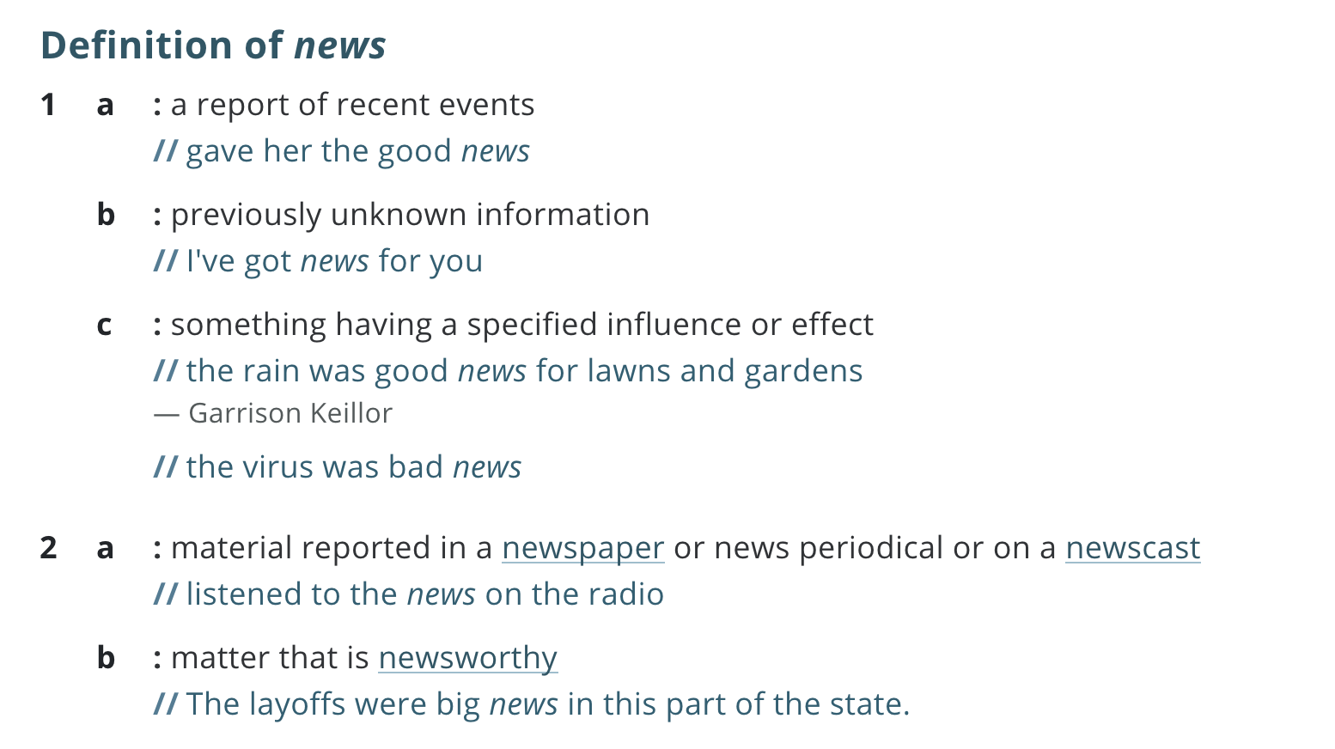

2. How do you get most of your news? Circle all that apply.
- Newspapers/magazines
- TV
- Internet/apps
- Radio
- Other
3. News outlets publish their news using all the different methods above. Make a list:
Which news outlets (newspapers, tv shows, websites, etc.) do you check to get your news?
-
-
-
- Compare your answers with this list from the Pew Research Center of the most widely read news websites in 2010! What are examples of stories you would see on the news? Write a few below.
-
-
-

4. Imagine you met someone today who has not looked at the news in over a week. Based on what you have heard about in the news over the last week, write your responses to the following:
What are the top three things a person needs to know about what is happening in the world this week?

How did you learn about these issues?

5. Respond to the following:
What stories do you see the most in the news?

How might the stories you chose differ from someone else in your class? Or in your family? Or from someone in another part of the world?

What is something that you think is important, but that you don’t see much about in the news?

Why do you think news outlets choose to feature some stories more than others?

5. An under-reported story is a news story that doesn’t get as much attention in the news. Predict:
- Look back to your responses for question 5. Why do you think news outlets are focusing on these stories, and not others?
- Why are some news stories receiving less attention? Try to think of at least three reasons!
-
-
-
7. The Pulitzer Center is a nonprofit organization that is dedicated to supporting under-reported stories. The Center supports projects in over 100 news outlets every year on a wide range of topics. Review this video below, which features Pulitzer Center editors and journalists, and compare your predictions about why some stories receive less attention to their response.
8. After viewing the video, write your responses to the questions below:
According to the speakers in the video, what is an under-reported story?

How are under-reported news stories different from other news stories? Reference examples from the video in your description.

How can you find under-reported stories, in the news and in your own communities?

Introducing the Skill: Finding and Evaluating Under-reported Stories
If under-reported stories communicate issues that don’t get a lot of attention, how do journalists find these stories in the first place? Where do they look? Who do they talk to? What kinds of questions do they ask themselves to decide if they want to pursue a story? In this lesson you will explore these questions by connecting with members of the editorial team at the Pulitzer Center, a nonprofit that raises awareness of under-reported global issues through direct support for quality journalism across all media platforms and a unique program of education and public outreach.
In this video, Pulitzer Center’s Managing Director Nathalie Applewhite and Executive Editor Marina Walker Guevara describe three ways to find under-reported stories that interest you. Watch the video, and evaluate how journalists use the following strategies to find under-reported stories:
- Analyze news and question what is missing
- Talk to people about issues that matter to them
- Observe the people and places around you, and get curious
After watching the video, write your responses to the following questions:
What questions can you ask yourself while watching the news to start noticing under-reported stories?

What is an example of an under-reported story investigated by a Pulitzer Center-supported journalist in response to the novel coronavirus? Why is this story considered under-reported?

What questions can you ask someone in your life to identify an under-reported story?

What was journalist Daniella Zalcman researching before she learned about the impacts of Canada’s Indian residential school program?

What questions can you ask yourself while observing your immediate environment to begin identifying under-reported stories?

What did journalist Sim Chi Yin observe in Beijing, and how did that inspire her photography project, “Beijing’s Rat Tribe?”

Which story cited in the video would you be most interested in exploring further, and why?

Which strategy would you most like to try to begin finding under-reported stories in your community?

Read and Analyze: How do you find and analyze under-reported stories?
The articles below were referenced by the editors in the video. Select one to read, and find the the associated PDF:
- “Health Care Workers Seek to Flatten COVID-19’s ‘Second Curve’ --Their Rising Mental Anguish” by Rodrigo Pérez Ortega for Science Magazine
- “El bus que nunca llega: Los migrantes varados en las calles de Lima tomada por la pandemia” by Musuk Nolte for Ojo Brujo (spanish)
- “Pictured with their Past: Survivors of Canadas’ ‘Cultural Genocide” Speak Out” by Daniella Zalcman for National Geographic
- “Beijing's Rat Tribe: The Chinese Dream Goes Underground” by Sim Chi Yin for Foreign Affairs

1. After reading, use the following questions to analyze the story you selected:

What details stood out to you from the story the journalist reported? Use these details to write a 3-5 sentence summary of the story.

Why do you think this qualifies as an under-reported story?

Why is this story important? What connections can you make between this story, and issues/people/places in your own community?

2. Optional Reading and Writing Extension: Select at least one of the articles below to analyze. Each article is by a journalist supported by the Pulitzer Center. As you review the article(s), respond to the following questions:

- “Land Grab Universities” by Tristan Ahtone for High Country News
- “America’s Clean Water Crisis Goes Far Beyond Flint. There’s No Relief in Sight” by Matt Black and Justin Worland for TIME Magazine
- “These Three Supertrees Can Protect Us from Climate Collapse” by Eliza Barclay, Umair Irfan and Tristan McConnell for Vox (interactive story viewable on Vox.com)
- “At What Cost? For Baltimore’s Poorest Families, the Child Support System Exacts a Heavy Price -- and It’s Hurting Whole Communities” by Yvonne Wenger for The Baltimore Sun
- “The Amazon’s Defenders” by Francesc Badia I Dalmases and Pablo Albarenga for The Washington Post

What details stood out to you from the story the journalist reported? Use these details to write a 3-5 sentence summary of the story.

Why do you think this story qualifies as an under-reported story?

What connections can you make between this story, and issues/people/places in your own community?

How do you think the journalist came up with the idea for this story?

4. Optional Reading and Writing Extension (continued): Using details from the articles you reviewed, write a short essay in the space below that compares and contrasts at least two articles to respond to the following:

- How do journalists identify under-reported stories?
- Why are under-reported stories important?

Practice: Find under-reported stories from where you are right now!
Use the exercises below to develop ideas for under-reported stories that you could investigate on your own.

1. Analyze news and question what is missing

- Review the front page(s) of a newspaper, a homepage of an online news site and an episode of a television news program. As you read/watch, make a list of the stories that received the most coverage.
-

-

-

- Pick one issue highlighted on the news, and use the following questions to identify an idea for an under-reported story connected to that issue.

What is happening, and why?

Who is affected, and why?

Who might be affected, but is not represented in these stories?

What do these issues look like in my community?

- Write a 3-5 sentence description below of your story idea that answers the following questions:

- What is the under-reported story you want to investigate?
- Why do you think this story is important?
- How would you research this story? Consider the following as you outline your plan: What online sources could you use to learn more? Who could you interview? Who is connected to this issue and how? What places might you visit to see the causes and impacts of this issue for yourself?

2. Talk to people about issues that matter to them

- Make a list of people you have seen in the last week. Consider, who do you want to know more about?
-

-

-

- Pick one or two people who you feel comfortable talking with, and use the following questions to guide your conversation:
  - What issues are important to you, and why?
  - What issues are impacting the people you know, and how?

- Use your interviews to identify an idea for an under-reported story. Write a 3-5 sentence description of your story idea below that answers the following questions:
  - What is the under-reported story you want to investigate?
  - Why do you think this story is important?
  - How would you research this story? Consider the following as you outline your plan:What online sources could you use to learn more? Who could you interview? Who is connected to this issue and how? What places might you visit to see the causes and impacts of this issue for yourself?
3. Observe the people and places around you, and get curious

- Make a list of the places that you have seen in the past day.
-

-

-

- Pick one of these places, and use the following questions to come up with an idea for an under-reported story that you could investigate on your own:
  - What doesn’t make sense to you?
  - What do you see that feels unfair or confusing?
  - What do you want to know more about?

- Write a 3-5 sentence description below of your story idea that answers the following questions:
  - What is the under-reported story you want to investigate?
  - Why do you think this story is important?
  - How would you research this story? Consider the following as you outline your plan.What online sources could you use to learn more? Who could you interview? Who is connected to this issue and how? What places might you visit to see the causes and impacts of this issue for yourself?

Extension Activities:
1. Embark on a reporting project:

Select at least one of the under-reported story ideas you identified, and use the following steps to report and share your story:

- Make a list of questions you have about the topic you selected. Conduct your own research to answer as many questions as you can.
- Make a list of people you could interview to learn more about your topic.
- Use your independent research and the responses to your interviews to write an article that shares your research and engages your readers. Not sure how to start? Try this resource from Scholastic.com

2. Research under-reported stories that interest you:

An important step in beginning to identify and analyze under-reported stories is to explore as many stories as you can. Use the graphic organizer below to analyze 5 under-reported stories supported by the Pulitzer Center. Try to select stories that interest you from our website, and that were published in different news outlets. After completing the graphic organizer, identify which story most connects to issues facing you and your community, and why.

Graphic Organizer: Analyzing Under-Reported Stories
1. Headline:

News Outlet: | Journalist(s):
Summary: (use at least 3 details from the reporting to capture its central message)

Reflect: Why did you choose to explore this story? How does this issue connect to you and your community?

2. Headline:

News Outlet: | Journalist(s):
Summary: (use at least 3 details from the reporting to capture its central message)

Reflect: Why did you choose to explore this story? How does this issue connect to you and your community?

3. Headline:

News Outlet: | Journalist(s):
Summary: (use at least 3 details from the reporting to capture its central message)

Reflect: Why did you choose to explore this story? How does this issue connect to you and your community?

4. Headline:

News Outlet: | Journalist(s):
Summary: (use at least 3 details from the reporting to capture its central message)

Reflect: Why did you choose to explore this story? How does this issue connect to you and your community?

5. Headline:

News Outlet: | Journalist(s):
Summary: (use at least 3 details from the reporting to capture its central message)

Reflect: Why did you choose to explore this story? How does this issue connect to you and your community?

CHALLENGE: Now that you’ve looked through a lot of different stories, identify which story most connects to issues facing you and/or your community. Use the space below, or another sheet of paper, to elaborate on how it connects your experiences or your community’s. Respond to the following in your description:
- What do the context in the story and your own have in common?
- What is different between them?
- What can you find out through research about how this issue affects other communities around the world?
Let us know what you think by emailing your writing to education@pulitzercenter.org! Be sure to include the reporting’s title and the journalist’s name.

